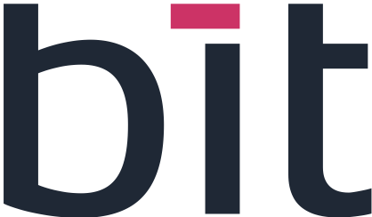 | 

INFINEON / BIT EXCELLENCE PROGRAM — 2026
WATER SUPPLY APP
Features Delivered

1. Backend Features Delivered
The backend is the part of the application that stores the data and applies the rules behind the screens. This week it was extended in five areas.
Plants
This module describes the blocks of plants on the farm and connects them to the water system.
- Link between zones and blocks — each irrigation zone can now be connected to a block of plants, so the water network and the plantation are tied together.
- Irrigations and consumption filtered by block — water used and irrigation events can be viewed block by block instead of only for the whole farm.
- Rainfall per block — rain is also recorded at block level, so each block knows how much water it received naturally.
- Water need per block based on growth stage — the amount of water a block needs is calculated according to the growth phase of its plants, since needs change as plants grow.
Visitor Management
This module lets the farm welcome visitors while keeping them informed about what the water system is doing around them.
- Irrigation status — shows whether irrigation is currently running.
- Live counter — a counter updated in real time that shows the water used during a visit.
- Visitor summary — a recap of the visit that can be shown to the visitor.
- Planned outages — scheduled water cuts can be recorded in advance.
- Visit announcements — messages announcing a visit.
- Safety instructions — instructions to be followed by visitors on site.
Product Transformation
This module links water use to the processing of products, so that the water used can be traced back to the batch it served.
- Batch and activity on consumption records — each water consumption can be tagged with the batch and the activity it was used for.
- Time slot linked to a batch — a period of time can be attached to a batch, to know when water was used for it.
- Water compliance — checks that the water used for a batch meets the required quality.
- Availability forecast — estimates whether enough water will be available for the planned processing.
Internal
These features work behind the scenes and are not tied to a single module.
- Level history — water levels are now saved over time, so their evolution can be reviewed.
- Automatic irrigation — irrigation starts on its own, and now takes planned outages and rainfall into account, so water is not wasted when it is not needed.
- Quotas per zone — each zone has its own water allowance that can be followed.
IoT
IoT is the link between the application and the physical equipment on the farm.
- Valve command — a command to a valve is now checked and recorded in a log. As long as no gateway (the device that connects the application to the equipment) is plugged in, the application answers with a 503 error, meaning the service is unavailable, instead of pretending the command worked.

2. Frontend
The frontend is what the user sees and uses on screen.
- Four new screens — Planned outages (to manage water cuts), Plants blocks (to manage blocks and their zones), Processing lots (to follow batches) and Visitors (to manage visits).
- Existing screens updated — they now also display the new data: block, batch, level history and forecast balance.
- Automatic location — the location of farms and fields is filled in automatically when they are created. The point is marked “to be reviewed” so that someone can confirm it.
- Fix when editing a farm — modifying a farm no longer makes it lose its position.

Summary in One Paragraph
In short
New backend features were delivered for plant blocks, visitor management, product transformation, internal automation and valve control through IoT. Four new screens were added in the frontend, the existing screens display the new data, and the location of farms and fields is now captured automatically.

